**Assignment -4**

|  |  |
| --- | --- |
| **ASSIGNMENT DATE** | 10-11-2022 |
| **STUDENT NAME** | ABISHEK S |
| **MAXIMUM MARK** | 2 MARKS |
| **TEAM ID** | PNT2022TMID33691 |

**Question-1:**

Pull an Image from docker hub and run it in docker playground.

**Solution:**

* Pull an image *uifd/ui-for-docker* from the docker hub
* This image is used for viewing and managing the docker engine
* Use docker pull image_name and docker run -it image_name commands to
* run the above image in the Docker Playground

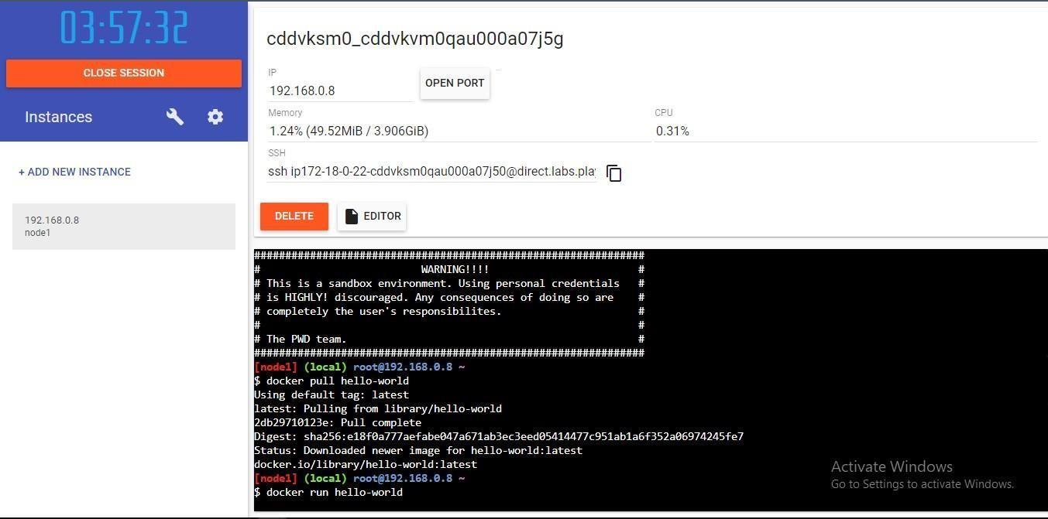

**Question-2:**

Create a docker file for the jobportal application and deploy it in Docker desktop application.

**Solution:**

* Create a docker file for build and deploy flask app.
* Use docker build -t image_name . in the current directory to start building the• docker image and deploy in our local docker
* Use docker run -p 5000:5000 image_name to run in local system

**CODE**

FROM ubuntu/apache2

FROM python

COPY ./requirements.txt /flaskApp/requirements.txt

WORKDIR /flaskApp

RUN pip install -r requirements.txt

COPY . /flaskApp

ENTRYPOINT [ "python" ]

CMD ["app.py" ]

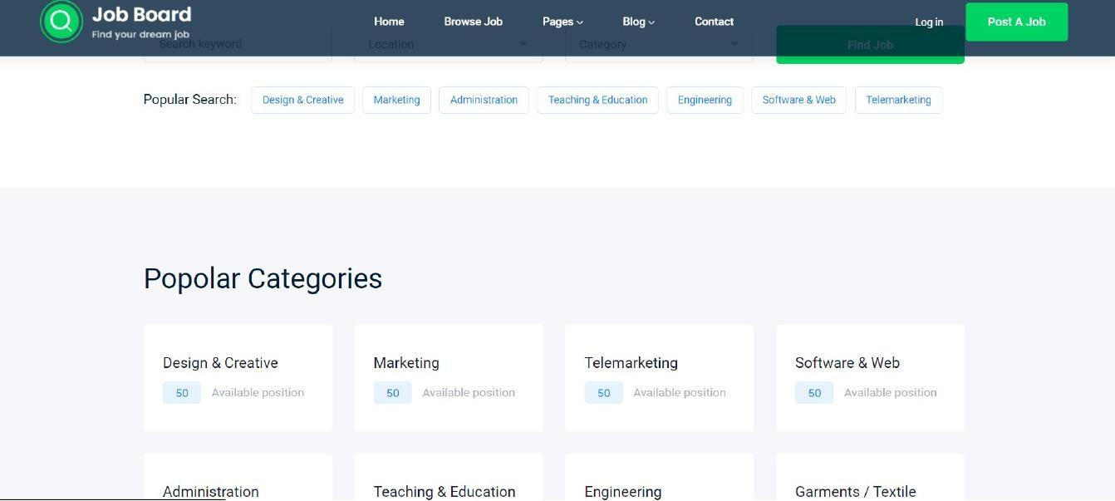

**Question-3:**

Create a IBM container registry and deploy hello world app or job portal app.

**Solution:**

* Log into IBM cloud
* Create a container registry
* Using IBM Cloud CLI, install the container registry plugin in our system
* Push our docker image into the created container registry using docker push
* So, our job portal app is deployed in the IBM container registry

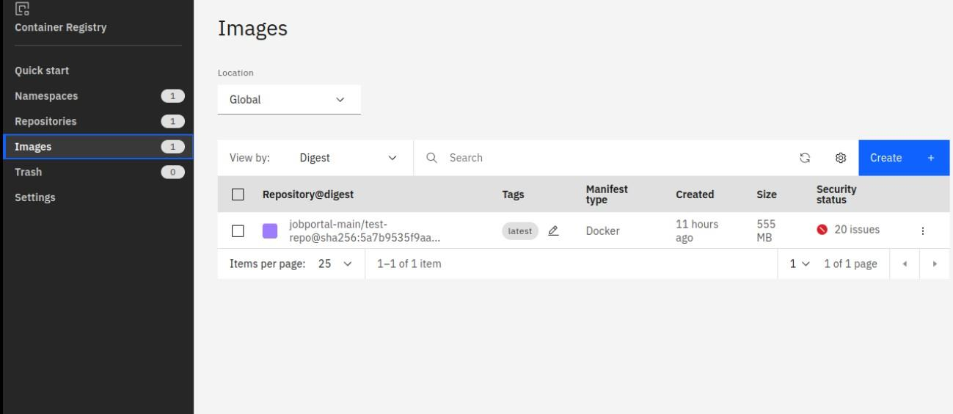

**OUTPUT:**

“HELLO WORLD”



**Question-4:**

Create a Kubernetes cluster in IBM cloud and deploy helloworld image or jobportal image and also expose the same

app to run in nodeport.

**Solution:**

* Log into IBM cloud
* Create a kubernete
* Using IBM Cloud CLI, install the ks plugin in our system
* Create a cluster in the kubernetes
* Now, go to the kubernetes dashboard where we need to create a service based on a
* yml file (given below)
* In that file, we have to mention *which image we are going to use* and the *app name*
* Take the public IP address and Nodeport since we exposed the *flask app in nodeport*
* Finally, we got the url address where our flask app is hosted

**CODE:**

apiVersion: v1

kind: Service

metadata:

name: job-portal-app

spec:

selector:

app: job-portal-app

ports:

- port: 5000

type: NodePort

---

apiVersion: apps/v1

kind: Deploymentmetadata:

name: job-portal-app

labels:

app: job-portal-app

spec:

selector:

matchLabels:

app: job-portal-app

replicas: 1

template:

metadata:

labels:

app: job-portal-app

spec:

containers:

- name: job-portal-app

image: image_name

ports:

- containerPort: 5000

env:

- name: DISABLE_WEB_APP

value: "false"

